**2019 Kentland Beef & Forage Day**

Hosted by

Virginia Cooperative Extension & the Virginia Tech College of Agriculture and Life Sciences

**September 17, 2019**

**Virginia Tech’s Kentland Farm**

**Blacksburg, VA**

**Demonstrations and workshops on:**

* **Extending the grazing season**
* **Fencing tools and techniques**
* **Grazing summer annuals**
* **Converting forest to pasture**
* **Using drones to assess pasture health**
* **Industrial Hemp**
* **Orchard production**
* **Whole Farm Tour**

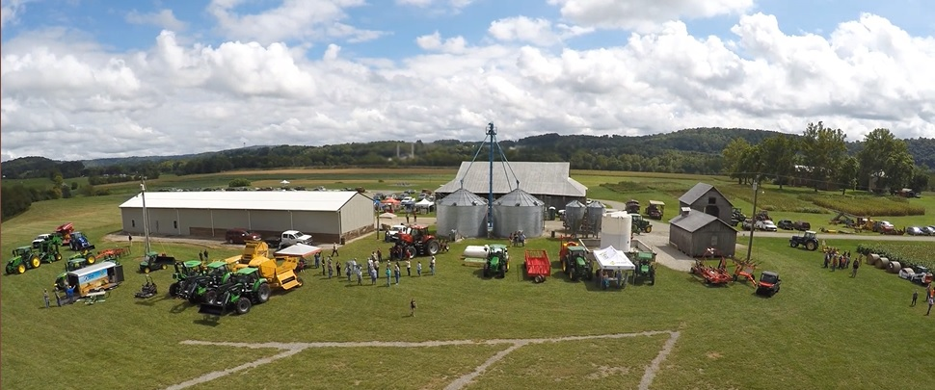

***Please Register by September 10th:***

Pulaski Extension Office

540-980-7761 or [paulette@vt.edu](mailto:paulette@vt.edu)

$10/person – Lunch Provided

